3. Code Maintenance

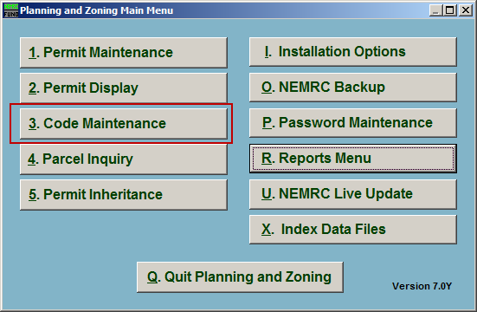
Click on “3. Code Maintenance” from the Main Menu and the following window will appear:

Code Maintenance

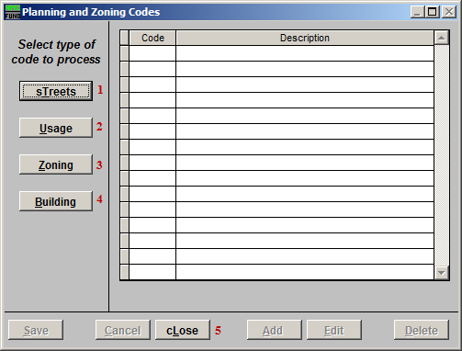
- sTreets: Click this button to edit Street Codes and their descriptions.

- Usage: Click this button to edit Usage Codes and their descriptions.

- Zoning: Click this button to edit Zoning Codes and their descriptions.

- Building: Click this button to edit Building Codes and their descriptions.

- cLose: Click this button o close and return to the Main Menu.

Streets

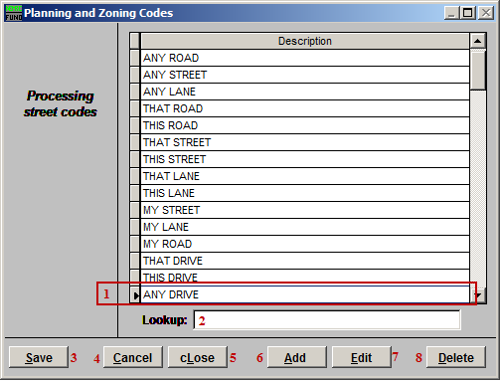
- Select the Street you wish to edit by clicking on it. You may then change the Description.

- Lookup: You may enter any partial street name in this field and the list will automatically scroll to the closest matching street name.

- Save: Click this button to save any changes and return to the previous screen.

- Cancel: Click “Cancel” to cancel and return to the previous screen.

- cLose: Click this button to close without saving and return to the Main Menu.

- Add: Click this button to add a new Street Description to the list.

- Edit: Click this button to edit the selected Street Description.

- Delete: Click this button to delete the selected Street Description.

Usage

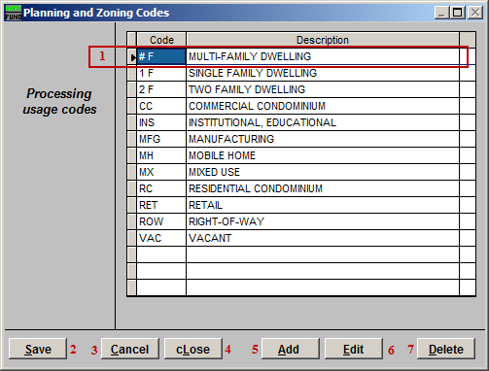
- Click to select and edit a Usage Code from the list.

- Save: Click this button to save any changes and return to the previous screen.

- Cancel: Click “Cancel” to cancel and return to the previous screen.

- cLose: Click this button to close without saving and return to the Main Menu.

- Add: Click this button to add a new Usage Code Description to the list.

- Edit: Click this button to edit the selected Usage Code Description.

- Delete: Click this button to delete the selected Usage Code Description.

Zoning

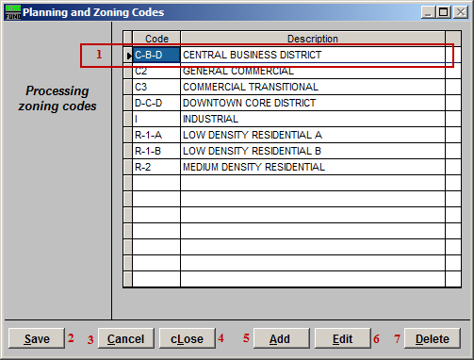
- Click to select and edit a Zoning Code from the list.

- Save: Click this button to save any changes and return to the previous screen.

- Cancel: Click “Cancel” to cancel and return to the previous screen.

- cLose: Click this button to close without saving and return to the Main Menu.

- Add: Click this button to add a new Zoning Code Description to the list.

- Edit: Click this button to edit the selected Zoning Code Description.

- Delete: Click this button to delete the selected Zoning Code Description.

Building

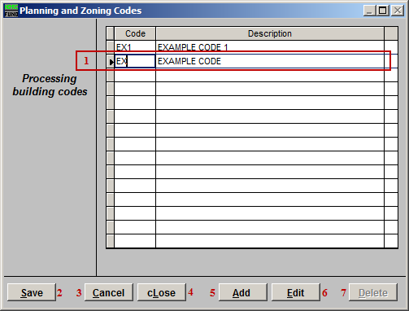
- Click to select and edit a Building Code from the list.

- Save: Click this button to save any changes and return to the previous screen.

- Cancel: Click “Cancel” to cancel and return to the previous screen.

- cLose: Click this button to close without saving and return to the Main Menu.

- Add: Click this button to add a new Building Code Description to the list.

- Edit: Click this button to edit the selected Building Code Description.

- Delete: Click this button to delete the selected Building Code Description.

